COMPUTER NETWORKS LAB
TASK 5
UDP HEADER INSPECTION
USING WIRESHARK
UDP ports • UDP length • Payload length • Large datagrams • DNS / mDNS

Name | Kasireddy Srihitha
Roll Number | 2520030153
Section | Sec - 7

1. AIM
To inspect UDP headers in the supplied Wireshark capture, record source port, destination port, UDP length and payload length for five packets, investigate large UDP datagrams, identify the largest payload that can be confirmed from the inspected packet details, and locate DNS-related traffic.

2. SOFTWARE / INPUT REQUIRED
- Wireshark network protocol analyser.
- Capture file: CN_Lab1.pcapng.
- Display filters: udp, udp.length > 1000, udp.length > 1432, udp.length > 1440 and dns.

3. PROCEDURE
- Open Wireshark and load CN_Lab1.pcapng.
- Enter udp in the Display Filter bar and press Enter. Confirm that the filter bar turns green.
- Select a UDP packet in the Packet List pane. Expand User Datagram Protocol in the Packet Details pane.
- Record Source Port, Destination Port and Length. Record the UDP payload length shown below the UDP header.
- Repeat the inspection for five UDP packets and enter the values in the observation table.
- Apply udp.length > 1000 to display large UDP datagrams. Narrow the results with udp.length > 1432 and udp.length > 1440.
- Inspect the packet list and select a large datagram. Verify its UDP Length and UDP payload fields in Packet Details.
- Apply dns to locate packets decoded as DNS traffic. The capture also shows multicast DNS (mDNS) traffic, identified by the MDNS protocol label and UDP port 5353.

4. OBSERVATION TABLE
Five UDP packets were selected from the capture. UDP payload length is calculated by subtracting the 8-byte UDP header from the UDP Length field.
Packet No. | Source Port | Destination Port | UDP Length | Payload Length | Protocol / Note
2 | 5353 | 5353 | 301 bytes | 293 bytes | mDNS response
3 | 5353 | 5353 | 314 bytes | 306 bytes | mDNS response
5 | 53311 | 22222 | 36 bytes | 28 bytes | UDP
6 | 53312 | 22222 | 36 bytes | 28 bytes | UDP
7 | 53313 | 22222 | 36 bytes | 28 bytes | UDP

Calculation: UDP payload length = UDP Length − 8 bytes. For Packet 3: 314 − 8 = 306 bytes.

5. UDP PACKET INSPECTION EVIDENCE
The screenshots below show the UDP display filter, selected UDP header fields and the packet list used to record the observations.
SCREENSHOT 1: UDP PACKET LIST AND PACKET 2 DETAILS
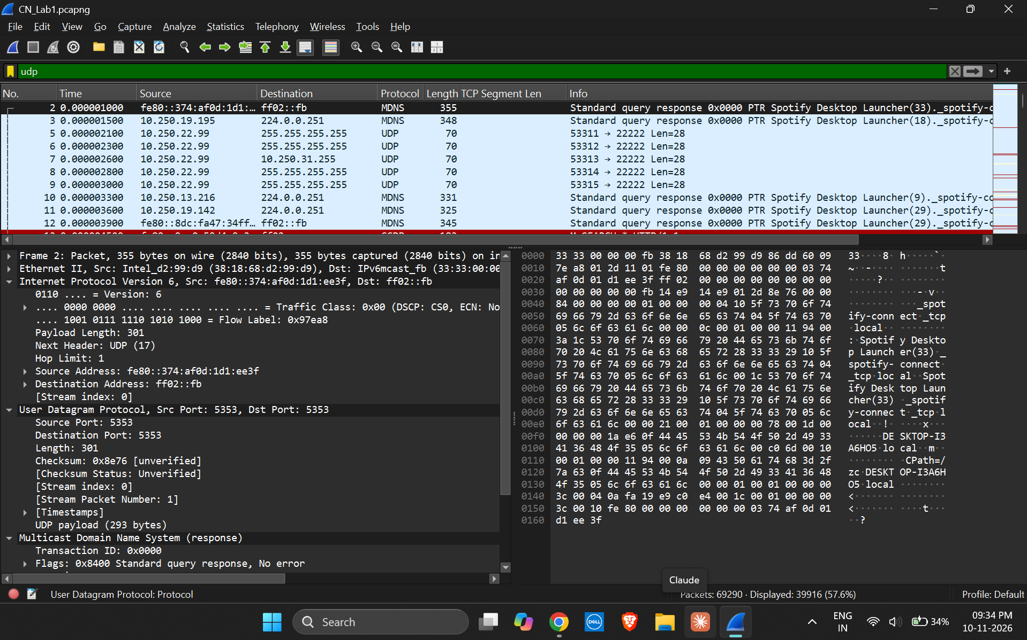
The udp filter is active. Packet 2 shows source and destination ports 5353, UDP Length 301 bytes and UDP payload 293 bytes.
SCREENSHOT 2: PACKET 3 UDP HEADER DETAILS
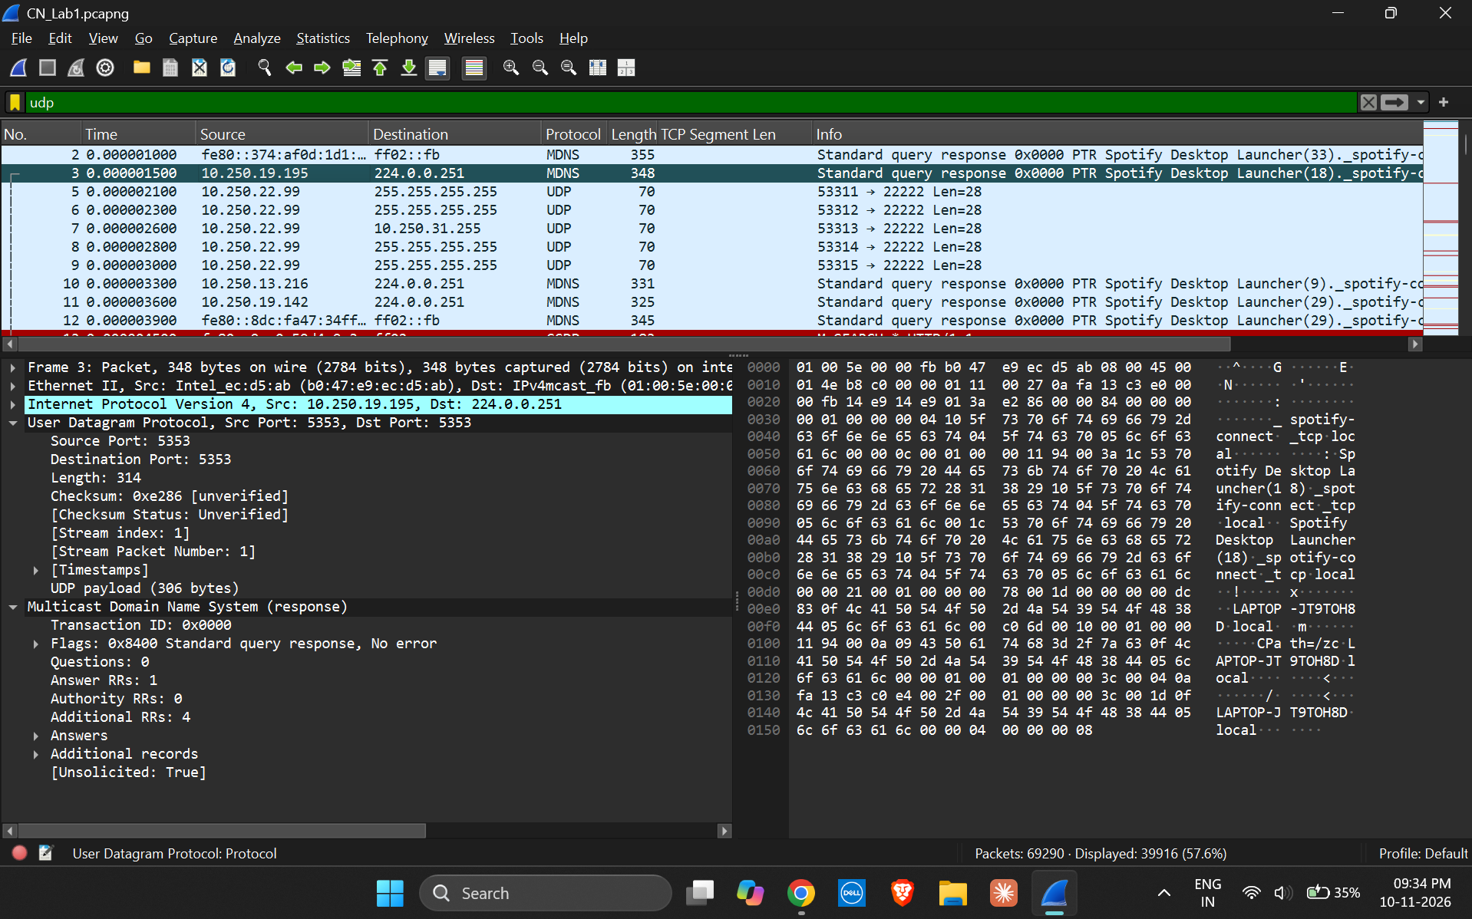
Packet 3 shows source and destination ports 5353, UDP Length 314 bytes and UDP payload 306 bytes.

6. LARGE UDP DATAGRAM ANALYSIS
The filter udp.length > 1432 displayed 202 packets. In the selected Packet 11399, the UDP header shows source and destination ports 5353, UDP Length 1440 bytes and UDP payload 1432 bytes. This demonstrates how the filter narrows the capture to large UDP datagrams.
SCREENSHOT 3: FILTER udp.length > 1432
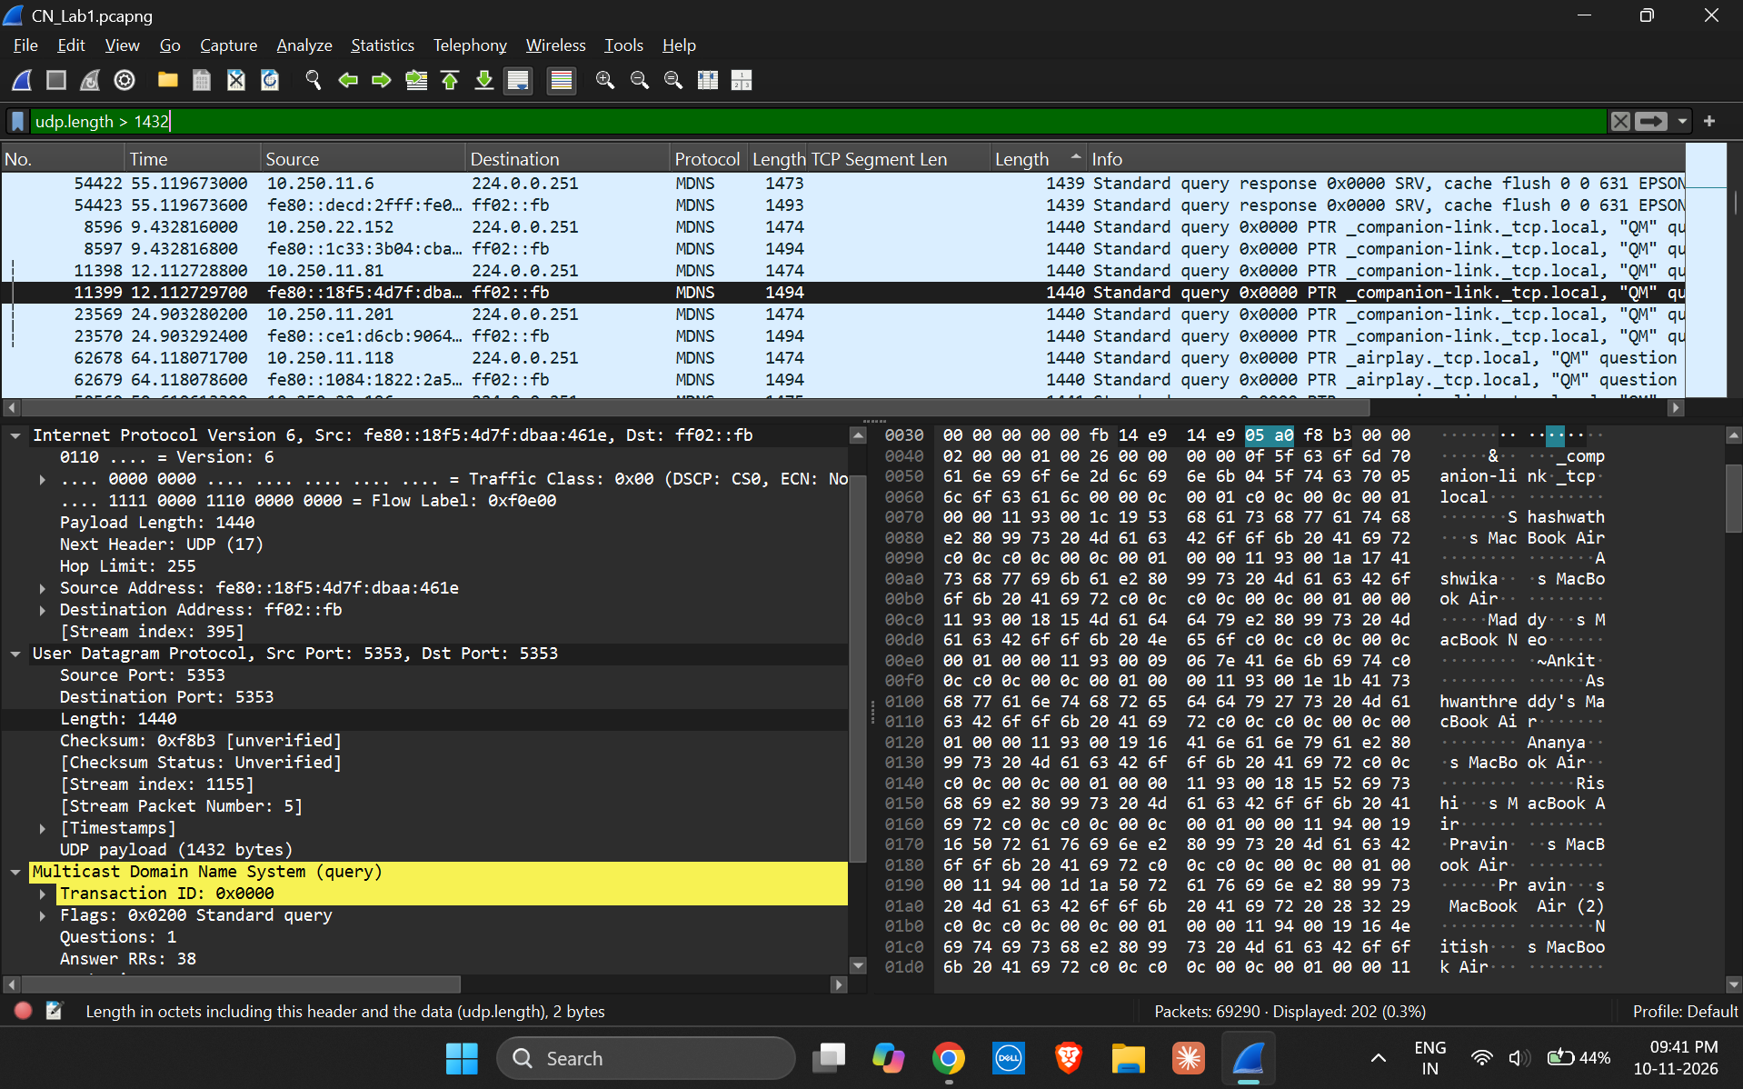
The filter bar shows udp.length > 1432, and the status bar reports 202 displayed packets. Packet 11399 has UDP Length 1440 bytes and payload 1432 bytes.
The filter udp.length > 1440 displayed 161 packets (0.2% of the 69,290 captured packets). Packet 10622 was selected for detailed inspection. Its UDP header shows UDP Length 1445 bytes and UDP payload 1437 bytes.
SCREENSHOT 4: FILTER udp.length > 1440 AND SELECTED LARGE UDP PACKET
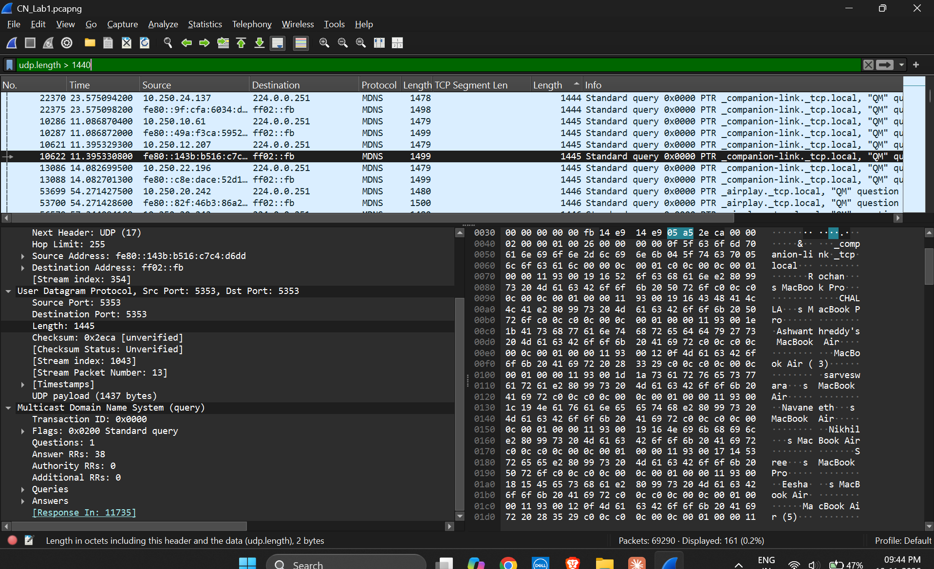
The status bar shows 161 displayed packets. Packet 10622 is selected; its UDP details show Length 1445 bytes and UDP payload 1437 bytes.
Maximum-payload verification note: The largest UDP payload directly verified in the selected packet details is 1437 bytes (Packet 10622). The filtered packet list also visibly contains a UDP Length value of 1446 bytes, but the corresponding packet details were not opened in the supplied screenshots. Therefore, 1437 bytes is the largest payload confirmed from a fully inspected packet, not a conclusively verified maximum for the entire capture. To establish the absolute maximum, sort the UDP Length column in descending order and inspect the first packet.

7. DNS TRAFFIC IDENTIFICATION
The capture contains Multicast DNS (mDNS) packets. Wireshark decodes these packets under “Multicast Domain Name System” and displays the protocol as MDNS. The inspected mDNS packets use UDP source and destination port 5353. The dns display filter can be entered to narrow the packet list to DNS-decoded traffic; mDNS is DNS-related multicast name-resolution traffic.

8. RESULT
UDP header fields were inspected and five packets were recorded. The UDP payload lengths were calculated by subtracting the 8-byte UDP header. Large-datagram filters reduced the displayed packet set to 202 packets for udp.length > 1432 and 161 packets for udp.length > 1440. Packet 10622 was verified with a UDP payload of 1437 bytes. mDNS traffic using UDP port 5353 was identified.

9. CONCLUSION
This activity demonstrated how Wireshark can be used to inspect UDP header fields, distinguish UDP length from payload length, filter large datagrams and identify multicast DNS traffic. The packet details confirm that the UDP header occupies 8 bytes, while the remaining UDP length represents payload data.

